First testing :
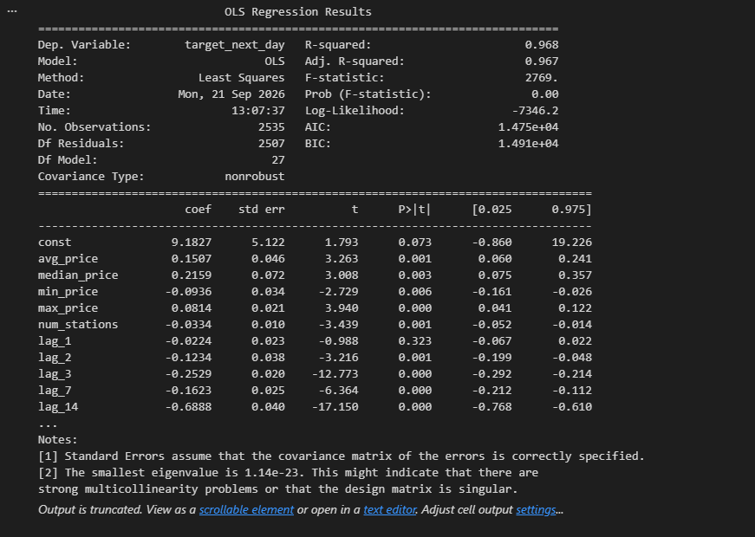
- R² and Adj-R² ≈ 0.97 — the model explains almost all the variance in next-day price.
- F-statistic = 2769 (p ≈ 0) — the model as a whole is highly significant.
- Day-of-week dummies behave sensibly. Because the target is tomorrow’s price:
  - dow_1 = Tuesday → tomorrow is Wednesday (spike) → coefficient +9.91 ✓
  - dow_2 = Wednesday → tomorrow is Thursday (still high) → +8.10 ✓
  - dow_6 = Sunday → tomorrow is Monday (cheapest) → −4.76 ✓
but there is a lot of multicollinerity , the lag price have negative numbers in it , therefore a fix is needed , I choose prune the data , only keeping one repsentative from the group
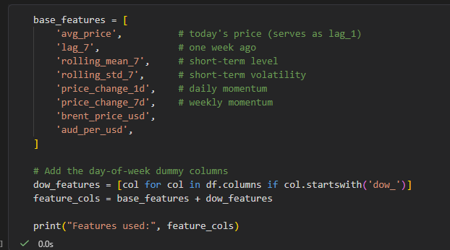
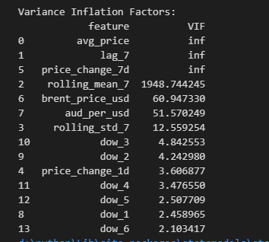
Second testing give me that
- avg_price, lag_7, price_change_7d → VIF = ∞ (inf) — perfect collinearity, as shown by the identity price_change_7d = avg_price − lag_7.
- rolling_mean_7 → VIF = 1948 — extreme, because it's essentially a smoothed version of avg_price.
- brent_price_usd (60.9) and aud_per_usd (51.6) — high but tolerable; they carry independent signal.
- Everything else (< 13) — acceptable.

So I remove the three infinite vif features

After pruning and few test later
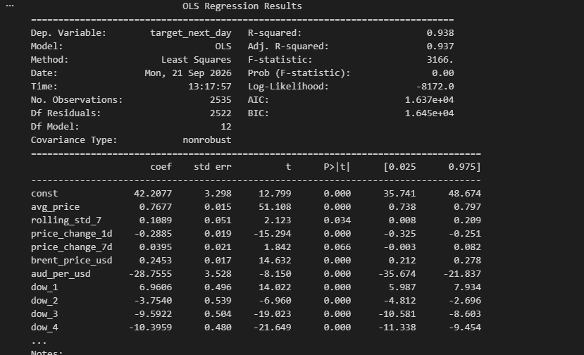

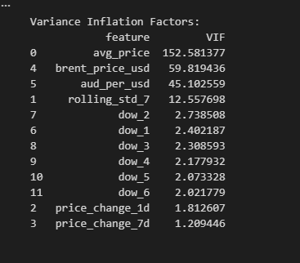
Demo interpretation:
1. Overall model fit
Statistic | Value | Interpretation
R² | 0.938 | 93.8% of the variance in next-day Perth ULP price is explained by the model. Very strong for a daily price series.
Adjusted R² | 0.937 | Barely different from R², meaning the model isn't over-fitting — every feature is pulling weight.
F-statistic | 3166 (p < 0.001) | The model as a whole is highly significant. At least one predictor has a real effect.
Condition number | 6.37 × 10³ | Moderate collinearity remains but is far from singular. Acceptable for a level-plus-change time-series specification.
Durbin-Watson | 2.088 | Very close to 2 → no meaningful first-order autocorrelation in residuals. Good.

2. Coefficient interpretation
2.1 Price persistence and momentum
Feature | Coefficient | Meaning
avg_price | +0.768 | For every 1 c/L higher today's price, tomorrow's price is expected to be 0.768 c/L higher, holding everything else fixed. Because the coefficient is less than 1, the model exhibits mean reversion: extremes are partially pulled back.
price_change_1d | −0.289 | If the price rose 1 c/L yesterday, tomorrow's price is expected to fall by 0.289 c/L. Captures short-term reversal — the sequence of daily rises/falls within the weekly cycle.
price_change_7d | +0.040 (p = 0.066) | Weak weekly momentum. Marginally significant — a 1 c/L rise over the past week nudges tomorrow's price up by 0.04 c/L. Not a dominant driver.
rolling_std_7 | +0.109 | Higher recent volatility tends to push tomorrow's price up slightly. Probably capturing periods of market stress where prices drift upward.
Interpretation: Perth ULP behaves like a persistent but mean-reverting series. Today's price dominates, and the model learns that yesterday's move partially reverses tomorrow.
2.2 External drivers
Feature | Coefficient | Meaning
brent_price_usd | +0.245 | A $1 USD rise in Brent crude raises tomorrow's Perth price by ≈0.25 c/L. Direction and size are economically plausible — Brent is the refined-product input benchmark.
aud_per_usd | −28.76 | A 0.01 increase in AUD/USD (AUD strengthening) reduces the Perth price by ≈0.29 c/L. Fuel is priced in USD, so a weaker AUD raises import costs. Sensible.
Interpretation: The external block is doing real work. Brent and the exchange rate carry independent information beyond the local price cycle, and both have the signs economics predicts. Their inclusion means the model isn't just memorising the weekly pattern.
2.3 Day-of-week dummies
Recall: each dummy is the expected change from today to tomorrow (relative to Monday), once the level is already accounted for.
Dummy | Today → Tomorrow | Coefficient | Meaning
dow_1 | Tue → Wed | +6.96 | The classic Wednesday spike: tomorrow's price jumps ~7 c/L. Highly significant (t = 14.0).
dow_2 | Wed → Thu | −3.75 | Partial reversal after the spike.
dow_3 | Thu → Fri | −9.59 | Continued decline.
dow_4 | Fri → Sat | −10.40 | Steady decline.
dow_5 | Sat → Sun | −9.82 | Steady decline.
dow_6 | Sun → Mon | −10.37 | Final leg down toward the weekly trough.
Interpretation: This is the model’s most compelling feature. Every dow dummy has the sign economics predicts, and all six are highly significant (|t| between 7 and 23). The weekly cycle you set out to capture is present and quantitatively identified in the coefficients.

3. Statistical significance summary
- Significant at p < 0.001: const, avg_price, price_change_1d, brent_price_usd, aud_per_usd, all six dow dummies.
- Significant at p < 0.05: rolling_std_7 (p = 0.034).
- Marginally significant (p ≈ 0.07): price_change_7d.
- Non-significant: none remain — you removed them during pruning.
Takeaway: every feature in the model contributes meaningfully.

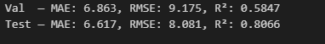
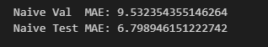

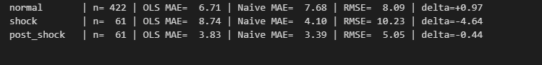
"The OLS model exhibits a strong competitive advantage over naive persistence during normal market conditions (Δ MAE = +0.97 c/L), but this advantage collapses during the 2026 Middle East conflict shock (Δ MAE = −4.64 c/L) because the model's mean-reverting structure cannot anticipate a sustained upward structural break. This confirms that the weekly-cycle signal that dominates in normal times is overwhelmed by exogenous shocks, a limitation that any cycle-based forecasting model must acknowledge."

